Test Case: tc002_SPX_Dev5_Crear_Requisicion_Spot_Tipo_Cobro_Project
Step 1 - Enter username and password and click to button Enter: Credentials Entered
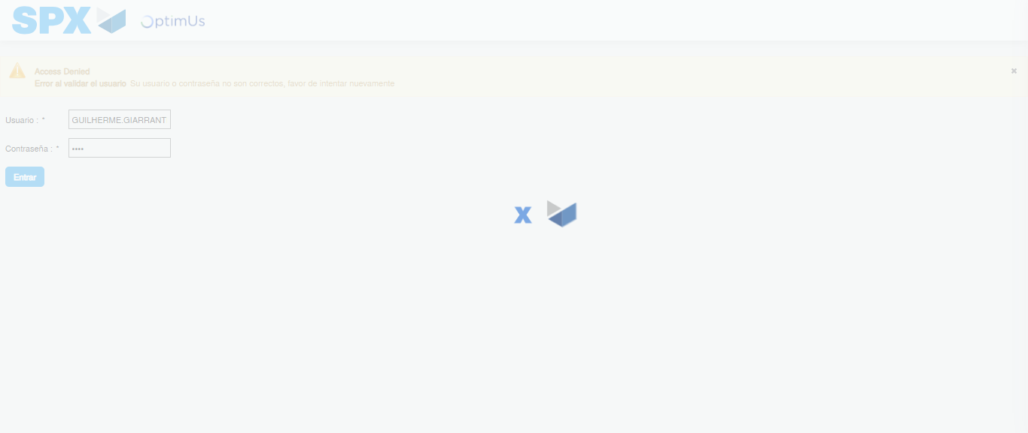Image file-name: QC_Testing-tc002_SPX_Dev5_Crear_Requisicion_Spot_Tipo_Cobro_Project-1784309300443

Step 2 - Select to UEN and Access to Spot Buy Requisitions : UEN Correctly selected and Correct access
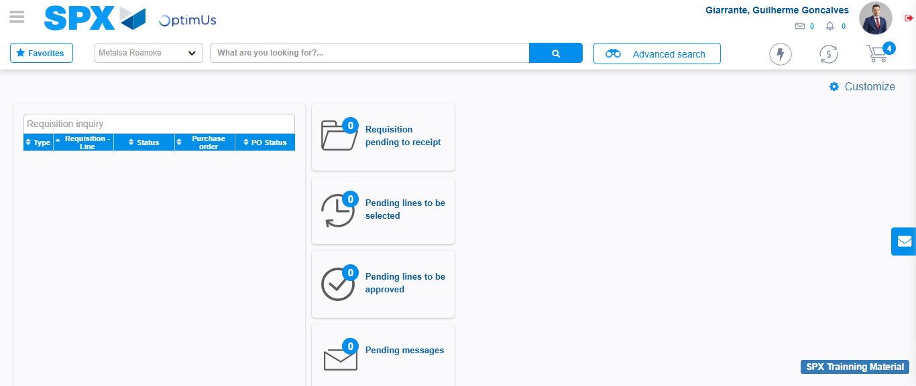Image file-name: QC_Testing-tc002_SPX_Dev5_Crear_Requisicion_Spot_Tipo_Cobro_Project-1784309328396

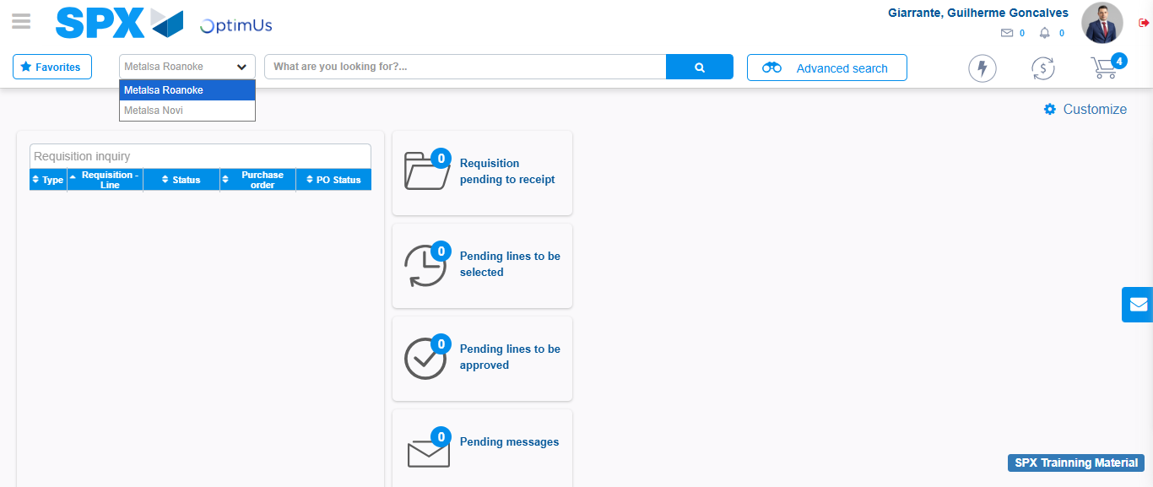Image file-name: QC_Testing-tc002_SPX_Dev5_Crear_Requisicion_Spot_Tipo_Cobro_Project-1784309331007

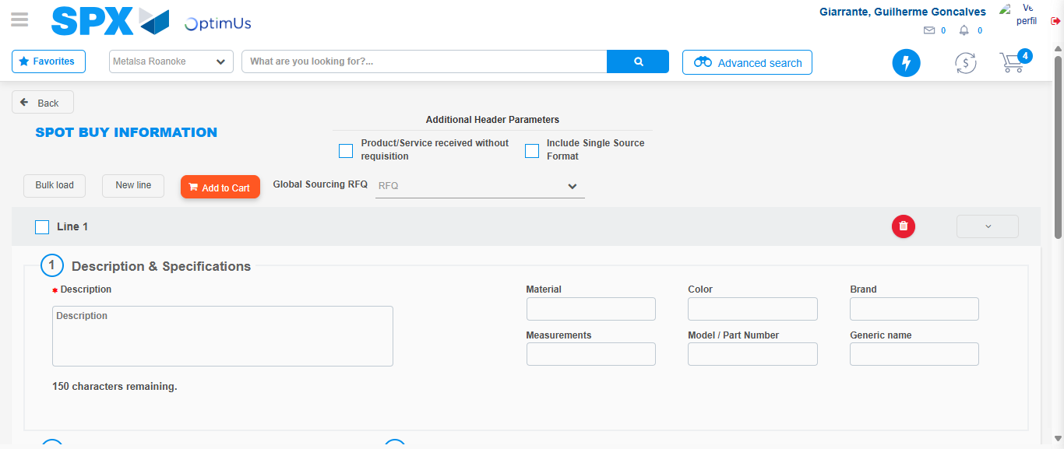Image file-name: QC_Testing-tc002_SPX_Dev5_Crear_Requisicion_Spot_Tipo_Cobro_Project-1784309366940

Step 3 - Data Capture Spot Buy Requisition: Data captured correctly
Image file-name: QC_Testing-tc002_SPX_Dev5_Crear_Requisicion_Spot_Tipo_Cobro_Project-1784309367237

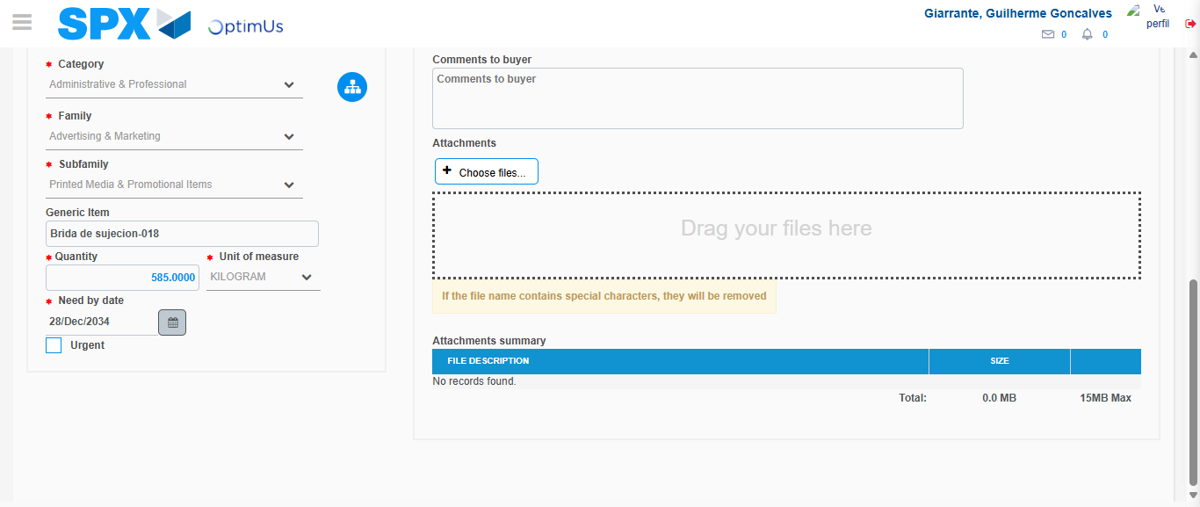Image file-name: QC_Testing-tc002_SPX_Dev5_Crear_Requisicion_Spot_Tipo_Cobro_Project-1784309381444

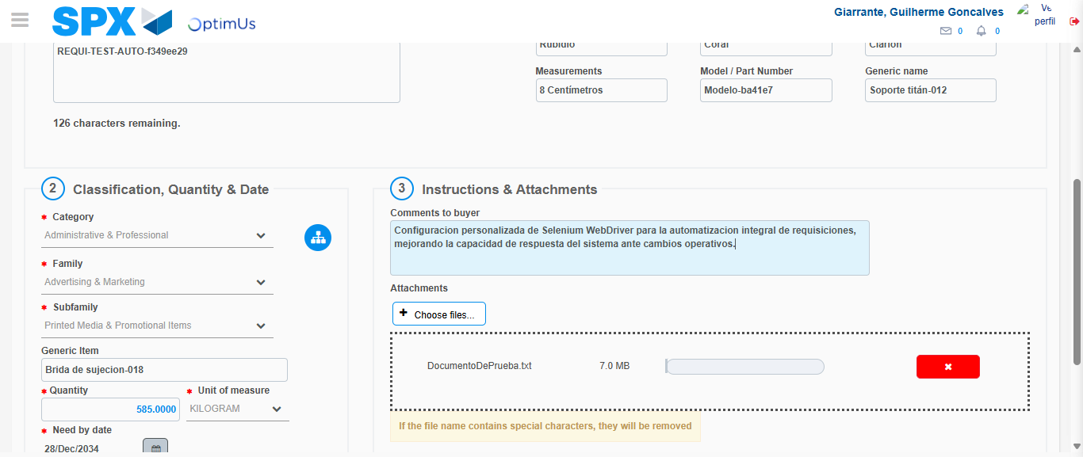Image file-name: QC_Testing-tc002_SPX_Dev5_Crear_Requisicion_Spot_Tipo_Cobro_Project-1784309382406

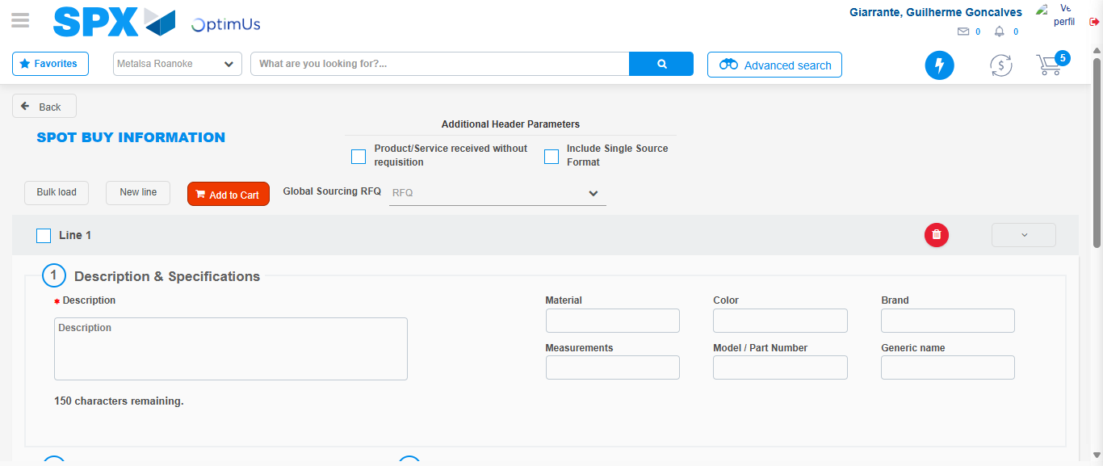Image file-name: QC_Testing-tc002_SPX_Dev5_Crear_Requisicion_Spot_Tipo_Cobro_Project-1784309388708

Step 7 - Return to Main Page SPX : Return to Main Page SPX
Image file-name: QC_Testing-tc002_SPX_Dev5_Crear_Requisicion_Spot_Tipo_Cobro_Project-1784309328396

Image file-name: QC_Testing-tc002_SPX_Dev5_Crear_Requisicion_Spot_Tipo_Cobro_Project-1784309331007

Image file-name: QC_Testing-tc002_SPX_Dev5_Crear_Requisicion_Spot_Tipo_Cobro_Project-1784309366940

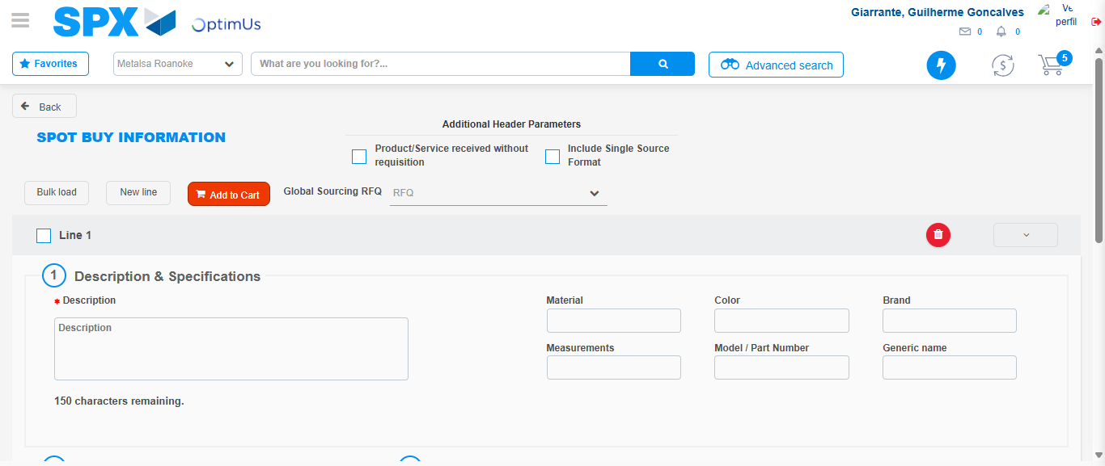Image file-name: QC_Testing-tc002_SPX_Dev5_Crear_Requisicion_Spot_Tipo_Cobro_Project-1784309390949

Image file-name: QC_Testing-tc002_SPX_Dev5_Crear_Requisicion_Spot_Tipo_Cobro_Project-1784309391195

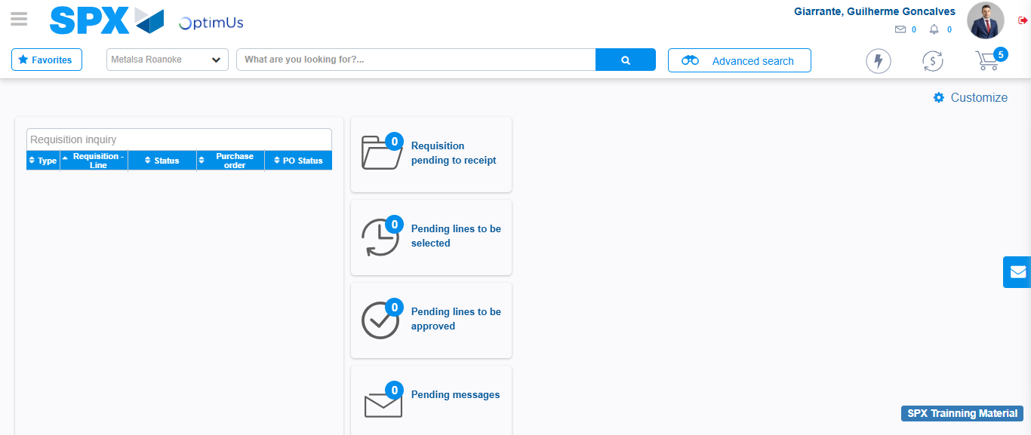Image file-name: QC_Testing-tc002_SPX_Dev5_Crear_Requisicion_Spot_Tipo_Cobro_Project-1784309412777

Step 8 - Log Out : Log Out SPX
Image file-name: QC_Testing-tc002_SPX_Dev5_Crear_Requisicion_Spot_Tipo_Cobro_Project-1784309413009

